CO2 AT2: SCENARIO BASED
1. Analyse type erasure and its practical effects on generic collections. Explain why new T(), T.class and arrays of a type parameter are restricted, and propose workarounds. [Analyse]
1. What is Type Erasure?
Type erasure is the process by which Java removes most generic type information during compilation.
For example:
List<String> names = new ArrayList<>();
List<Integer> numbers = new ArrayList<>();
At compile time, Java knows:
- names stores String
- numbers stores Integer
But after compilation, both are essentially treated as:
List
The generic information <String> and <Integer> is erased from the runtime representation.
Why does Java use type erasure?
Java introduced generics while maintaining compatibility with older Java programs.
Before generics:
List list = new ArrayList();
list.add("Apple");
With generics:
List<String> list = new ArrayList<>();
list.add("Apple");
Type erasure allows old non-generic Java bytecode and newer generic code to work together.
2. Example of Type Erasure
Consider:
class Box<T> {
private T value;

public void set(T value) {
this.value = value;
}

public T get() {
return value;
}
}
We can create:
Box<String> stringBox = new Box<>();
Box<Integer> integerBox = new Box<>();
At compile time:
Box<String>
Box<Integer>
But after type erasure, the JVM essentially sees:
Box
Box
The compiler inserts the necessary casts when retrieving values.
For example:
String name = stringBox.get();
is conceptually handled as:
String name = (String) stringBox.get();
So generics mainly provide compile-time type safety, while the JVM generally does not retain the complete generic type information.
3. Practical Effect on Generic Collections
Consider an ArrayList:
ArrayList<String> names = new ArrayList<>();
names.add("Nikitha");
names.add("Riya");
names.add("Anu");
The compiler prevents:
names.add(100);
because 100 is an integer, not a String.
However, at runtime, the JVM does not have a separate:
ArrayList<String>
class and:
ArrayList<Integer>
class.
Both are based on:
ArrayList
This is one of the major practical effects of type erasure.
Important point
Generics provide:
Compile-time type checking, not complete runtime generic type information.
4. Why is new T() Restricted?
Suppose we write:
class Box<T> {
T value;

T create() {
return new T();
}
}
This produces a compilation error.
Why?
The compiler does not know what T actually represents at runtime.
For example:
Box<String>
would require:
new String()
while:
Box<Student>
would require:
new Student()
The compiler cannot simply generate:
new T();
because T is erased.
Therefore Java does not allow:
new T();
5. Workaround for new T()
Method 1: Pass a constructor using Supplier<T>
This is one of the cleanest modern solutions.
Program
import java.util.function.Supplier;

class Box<T> {
private T value;

public T create(Supplier<T> supplier) {
value = supplier.get();
return value;
}
}

public class Main {
public static void main(String[] args) {

Box<String> box = new Box<>();

String result = box.create(() -> new String("Hello"));

System.out.println("Created object: " + result);
}
}
Output
Created object: Hello
Here:
Supplier<T>
provides the actual object creation logic.

6. Another Workaround Using Class<T>
We can pass the class information explicitly.
class Factory<T> {

private Class<T> type;

Factory(Class<T> type) {
this.type = type;
}

T create() throws Exception {
return type.getDeclaredConstructor().newInstance();
}
}

public class Main {
public static void main(String[] args) throws Exception {

Factory<String> factory = new Factory<>(String.class);

String value = factory.create();

System.out.println("Created object: " + value);
}
}
Output
Created object:
The String object is successfully created.

7. Why is T.class Restricted?
Consider:
class Test<T> {

void display() {
System.out.println(T.class);
}
}
This is not allowed.
Why?
Because after type erasure, T does not have a specific runtime class.
Suppose:
Test<String>
and:
Test<Integer>
At runtime, both use the same generic class.
The JVM cannot treat:
T.class
as either:
String.class
or:
Integer.class
automatically.
Therefore:
T.class
is prohibited.

8. Workaround for T.class
Pass Class<T> to the generic class.
Program
class Test<T> {

private Class<T> type;

Test(Class<T> type) {
this.type = type;
}

void displayType() {
System.out.println("Type: " + type.getName());
}
}

public class Main {
public static void main(String[] args) {

Test<String> test = new Test<>(String.class);

test.displayType();
}
}
Output
Type: java.lang.String
Here:
String.class
is explicitly passed to:
Test<String>
So the runtime has the required class information.

9. Why Are Arrays of Type Parameters Restricted?
Consider:
class Storage<T> {

T[] data = new T[10];
}
This is not allowed.
The compiler produces an error similar to:
Generic array creation
Why?
Arrays are reified in Java.
That means arrays remember their component type at runtime.
For example:
String[] names = new String[10];
The JVM knows:
This is a String array.
But due to type erasure, the JVM does not know whether:
T
is:
String
Integer
Student
etc.
Therefore Java cannot safely create:
new T[10]

10. Why This Can Cause Problems
Suppose Java allowed:
T[] array = new T[10];
Now imagine:
Storage<String>
and:
Storage<Integer>
At runtime, the JVM would need to know whether the underlying array should be:
String[]
or:
Integer[]
But the type parameter has been erased.
This creates a conflict between:
Generic type erasure
and
Runtime type information required by arrays
Therefore Java restricts generic array creation.

11. Workaround for Generic Arrays
Method 1: Use Object[]
A common workaround is:
class Storage<T> {

private Object[] data;

Storage(int size) {
data = new Object[size];
}

public void set(int index, T value) {
data[index] = value;
}

@SuppressWarnings("unchecked")
public T get(int index) {
return (T) data[index];
}
}

public class Main {
public static void main(String[] args) {

Storage<String> storage = new Storage<>(3);

storage.set(0, "Apple");
storage.set(1, "Banana");
storage.set(2, "Mango");

System.out.println(storage.get(0));
System.out.println(storage.get(1));
System.out.println(storage.get(2));
}
}
Output
Apple
Banana
Mango
Here the actual array is:
Object[]
and the generic type is checked when values are retrieved.

12. Method 2: Use Array.newInstance()
If you specifically need an array of the actual runtime type, pass Class<T>.
Program
import java.lang.reflect.Array;

class GenericArray<T> {

private T[] array;

GenericArray(Class<T> type, int size) {
array = (T[]) Array.newInstance(type, size);
}

public void set(int index, T value) {
array[index] = value;
}

public T get(int index) {
return array[index];
}
}

public class Main {
public static void main(String[] args) {

GenericArray<String> names =
new GenericArray<>(String.class, 3);

names.set(0, "Nikitha");
names.set(1, "Riya");
names.set(2, "Anu");

System.out.println(names.get(0));
System.out.println(names.get(1));
System.out.println(names.get(2));
}
}
Output
Nikitha
Riya
Anu
The important statement is:
Array.newInstance(type, size)
If:
type = String.class
the JVM creates a real:
String[]
array.

13. Three Main Restrictions at a Glance
Expression | Allowed? | Reason
new T() | ❌ No | Runtime doesn't know actual type of T
T.class | ❌ No | Class literal requires a concrete runtime class
new T[10] | ❌ No | Arrays require runtime component-type information

14. Workarounds at a Glance
Restriction | Workaround
new T() | Supplier<T>
new T() | Pass Class<T> + reflection
T.class | Pass Class<T>
new T[10] | Use Object[]
new T[10] | Array.newInstance()

15. Complete Demonstration Program
For an assignment, you can combine the concepts into one program.
import java.lang.reflect.Array;
import java.util.function.Supplier;

class GenericDemo<T> {

private Class<T> type;
private T[] array;

GenericDemo(Class<T> type, int size) {

this.type = type;

array = (T[]) Array.newInstance(type, size);
}

// Workaround for new T()
public T create(Supplier<T> supplier) {
return supplier.get();
}

// Workaround for T.class
public void displayType() {
System.out.println("Runtime type: " + type.getName());
}

// Workaround for generic array creation
public void set(int index, T value) {
array[index] = value;
}

public T get(int index) {
return array[index];
}
}

public class Main {

public static void main(String[] args) {

GenericDemo<String> demo =
new GenericDemo<>(String.class, 3);

// T.class workaround
demo.displayType();

// new T() workaround
String value = demo.create(() -> new String("Hello"));

System.out.println("Created object: " + value);

// Generic array workaround
demo.set(0, "Apple");
demo.set(1, "Banana");
demo.set(2, "Mango");

System.out.println("Array elements:");

System.out.println(demo.get(0));
System.out.println(demo.get(1));
System.out.println(demo.get(2));
}
}
Output
Runtime type: java.lang.String
Created object: Hello
Array elements:
Apple
Banana
Mango

OUTPUT SCREENSHOT:
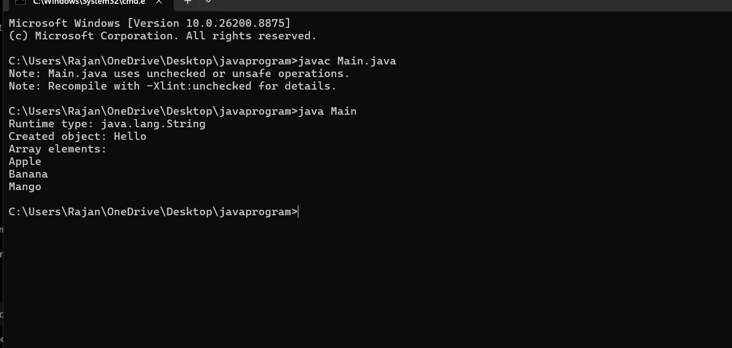

16. Step-by-Step Execution
Step 1 – Create generic object
GenericDemo<String> demo =
new GenericDemo<>(String.class, 3);
Here:
T = String
and:
String.class
is passed to the class.

Step 2 – Store runtime type
The constructor receives:
String.class
and stores it:
this.type = type;
Therefore the program has runtime information about String.

Step 3 – Create array
Normally this would be illegal:
new T[3]
Instead we use:
Array.newInstance(type, 3)
Since:
type = String.class
Java creates:
String[3]

Step 4 – Display type
demo.displayType();
prints:
Runtime type: java.lang.String
This replaces the unavailable:
T.class

Step 5 – Create an object
Instead of:
new T()
we use:
demo.create(() -> new String("Hello"));
The Supplier<T> provides the actual object.
Output:
Created object: Hello

Step 6 – Store values
demo.set(0, "Apple");
demo.set(1, "Banana");
demo.set(2, "Mango");
The generic array stores the String values.

Step 7 – Retrieve values
demo.get(0)
demo.get(1)
demo.get(2)
Output:
Apple
Banana
Mango

17. Practical Effects on Generic Collections
Type erasure has several important effects.
1. Type safety occurs at compile time
ArrayList<String> list = new ArrayList<>();

list.add("Hello");
This is valid.
But:
list.add(100);
causes a compilation error.

2. Generic type is not directly available at runtime
You cannot simply do:
if (list instanceof ArrayList<String>)
because Java does not retain enough runtime information to perform that check.
You can use:
if (list instanceof ArrayList<?>) {
System.out.println("It is an ArrayList");
}

3. Different generic types use the same runtime class
ArrayList<String> names = new ArrayList<>();
ArrayList<Integer> numbers = new ArrayList<>();
Both are runtime instances of:
ArrayList

4. Casts can be inserted by the compiler
When you write:
String name = list.get(0);
the compiler effectively ensures the returned object is treated as a String.
This is another way generic type safety works despite erasure.

18. Advantages of Type Erasure
Compatibility
It allows generic Java code to remain compatible with older Java bytecode.
Type safety
Incorrect types are detected during compilation.
No separate runtime classes
Java doesn't need separate runtime versions of:
ArrayList<String>
ArrayList<Integer>
ArrayList<Double>
Reduced runtime overhead
Generics don't generally require a separate specialized class for every parameterized type.

19. Limitations of Type Erasure
The major limitation is:
Generic type information is not fully available at runtime.
Therefore Java restricts:
new T()
T.class
new T[]
and certain runtime checks involving parameterized types.

20. Short Answer for Viva
If your teacher asks:
Why can't we use new T()?
Say:
Because of type erasure, the actual type represented by T is not known at runtime. Therefore Java cannot determine which constructor should be called. We can pass a Supplier<T> or Class<T> as a workaround.
Why can't we use T.class?
A class literal requires a concrete runtime type. Since T is erased, Java does not know whether it represents String, Integer, or another class. We can pass Class<T> explicitly.
Why can't we create new T[10]?
Arrays require their component type at runtime, but generic type parameters are erased. Therefore Java cannot safely create an array of T. We can use Object[] or Array.newInstance() with Class<T>.
What is type erasure?
Type erasure is the process where Java removes generic type information during compilation while inserting the necessary casts and maintaining compile-time type safety.

Conclusion
Type erasure allows Java generics to provide compile-time type safety while maintaining backward compatibility with older Java code. However, because the actual generic type is unavailable at runtime, Java restricts operations such as new T(), T.class, and new T[]. These restrictions can be overcome by explicitly supplying runtime type information through Class<T>, using Supplier<T> for object creation, or using Array.newInstance() for generic arrays.
This directly demonstrates the practical trade-off of Java generics: strong compile-time type checking but limited runtime knowledge of parameterized types.

